Project Design Phase-II
Data Flow Diagram & User Stories

Date | 19 September 2026
Student ID | 23NU1A4429
Project Name | Automated Network Request Management in ServiceNow
Maximum Marks | 4 Marks
Data Flow Diagrams:
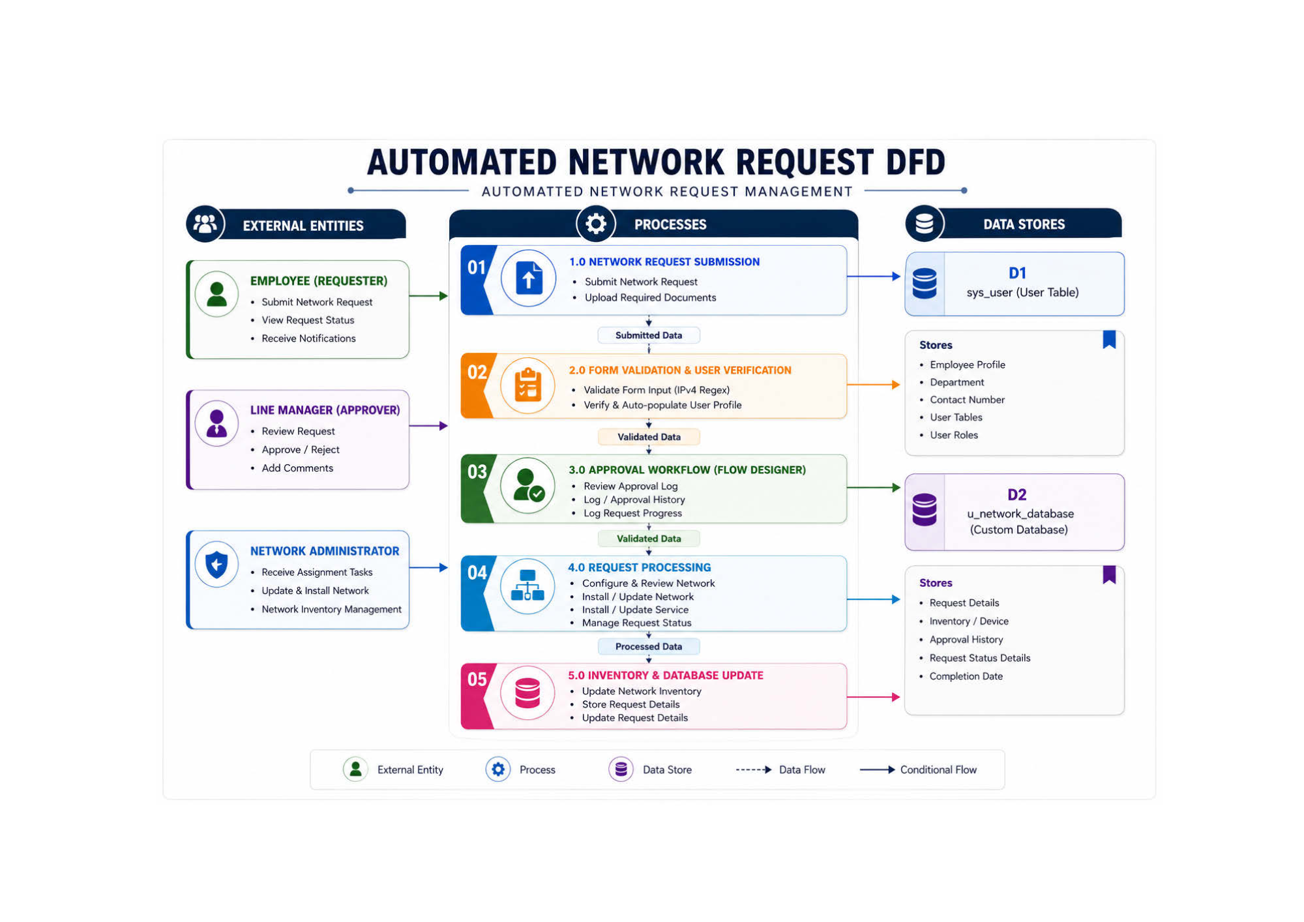
Data Flow Diagram (DFD) Specifications Report
Overview
The Data Flow Diagram (DFD Level-1) represents the structural architectural mechanics and information flow for the Automated Network Request Management System in ServiceNow. It tracks data ingestion from initial submission to verification, approval orchestration, fulfillment task creation, and permanent database commit.
Core Elements of DFD Level-1
1. External Entities (Actors)
• Employee (Requester): Initiates data ingestion workflows via Service Portal interactions (submits network requests, views real-time status updates, receives notifications).
• Line Manager (Approver): Authorizes or rejects execution path changes (reviews request parameters, approves/rejects, adds comments).
• Network Administrator (Fulfillment): Executes physical or logical network provisioning tasks (receives approved work orders, performs installation, updates asset inventory).
2. Processes (System Transformations)
• Process 1.0 (Network Request Submission): Front-end UI application captures request details, uploaded network architecture documents, and user login tokens.
• Process 2.0 (Form Validation & User Verification): Checks mandatory field inputs, executes IPv4 Regex validation, and auto-populates employee profile variables.
• Process 3.0 (Approval Workflow - Flow Designer): Executes business validation state gates, creates approval records (sysapproval_approver), and routes tasks to the designated Line Manager.
• Process 4.0 (Request Processing): Spawns catalog fulfillment tasks (sc_task), notifies the Network Operations Group, and updates request state to In-Progress.
• Process 5.0 (Inventory & Database Update): Commits approved values to permanent datastores and updates physical infrastructure inventory records.
• Process 6.0 (Notification & Request Closure): Issues completion notifications to the requester and closes out the parent requested item (sc_req_item).
3. Data Stores (Persistence Ledger)
• D1: sys_user (User Table): Core source profile repository storing employee names, email addresses, department assignments, phone numbers, and role permissions.
• D2: u_network_database (Custom Database Table): The ultimate permanent tracking schema ledger storing request details, hardware/device information, network port configurations, building locations, approval logs, and installation completion timestamps.
Execution Flow Summary
1. Request Ingestion: The Employee submits a network request through the Service Portal interface.
2. Profile Verification: Process 2.0 queries sys_user (D1) to auto-populate and verify employee credentials.
3. Approval Orchestration: Process 3.0 triggers Flow Designer, logging a pending state in u_network_database (D2) while awaiting Line Manager authorization.
4. Task Execution: Upon approval, Process 4.0 creates an sc_task assigned to the Network Administrator.
5. Database Commit: Process 5.0 writes final installation and port configuration details to u_network_database (D2).
6. Closure: System sends confirmation notifications to the requester and closes the ticket.

User Stories
User Type | Functional Requirement (Epic) | User Story Number | User Story / Task | Acceptance criteria | Priority | Release
Requester | Network Request Submission | USN-1 | As a requester, I can submit a Network Request through the ServiceNow Service Portal so that I can request network services without manual processing. | Network Request catalog item is accessible and the requester can successfully submit the form. | High | Sprint-1
 |  | USN-2 | As a requester, I can have my available requester information automatically populated so that I do not have to enter the same information repeatedly. | Relevant requester fields are automatically populated from the selected user information. | High | Sprint-1
 |  | USN-3 | As a requester, I can receive a REQ and RITM number after submitting my request so that I can identify and track it. | A valid REQ/RITM is generated and associated with the submitted Network Request. | High | Sprint-1
 | Request Information | USN-4 | As a requester, I can provide required network and customer information so that the IT team receives the details required for fulfillment. | Required catalog fields accept and retain the submitted values. | High | Sprint-1
Network Administrator | Automated Record Creation | USN-5 | As a network administrator, I want the system to automatically create a Network Database record when a Network Request is submitted so that manual record creation is eliminated. | A Network Database record is automatically created after successful request submission. | High | Sprint-2
 |  | USN-6 | As a network administrator, I want submitted catalog information to be automatically mapped to the Network Database fields so that information remains consistent. | Corresponding Network Database fields contain the values submitted through the catalog. | High | Sprint-2
 | Task Management | USN-7 | As a network administrator, I want the system to automatically create a Network Task record so that the request can be processed and fulfilled. | A Network Task is automatically created and linked to the corresponding request. | High | Sprint-2
 |  | USN-8 | As a network administrator, I want request information to be automatically populated in the Network Task so that I do not have to manually re-enter it. | Relevant requester, request, database, and service information is populated in the task. | High | Sprint-2
Approver | Approval Management | USN-9 | As an approver, I can review and approve or reject a network request so that only authorized requests proceed to fulfillment. | Approval status can be updated to the configured approval outcomes and the request proceeds accordingly. | High | Sprint-2
Network Administrator | Fulfillment & Tracking | USN-10 | As a network administrator, I can update the Network Task work status so that the progress of fulfillment is recorded. | Task status can move through the configured lifecycle, such as Work in Progress → Completed. | High | Sprint-3
 | Traceability | USN-11 | As a network administrator, I can trace the Network Task and Network Database record back to the original REQ/RITM so that the complete request lifecycle is identifiable. | REQ/RITM references are available in the corresponding operational records. | High | Sprint-3
Requester | Notification | USN-12 | As a requester, I receive an email when my Network Task is completed so that I know my request has been fulfilled. | When the task reaches the configured completed/resolved state, an email is automatically sent to the requester. | Medium | Sprint-3

